How to know your phone ID

For CDMA phone, the phone ID is MEID (length = 14).
For GSM phone, the phone ID is IMEI (length = 15).

Method 1
Enter *#06# on your phone’s dialer, which will pop up your MEID/IMEI.
On most phones, it works. If it does not, please try method 2, 3 or 4.

Method 2
Take off your phone back cover and buttery, there is a paster on which MEID/IMEI are printed.
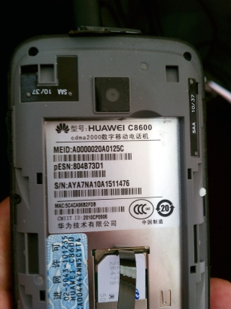

Method 3
From the home screen, press menu -> settings -> about phone -> status and you'll reach the following screen for example.
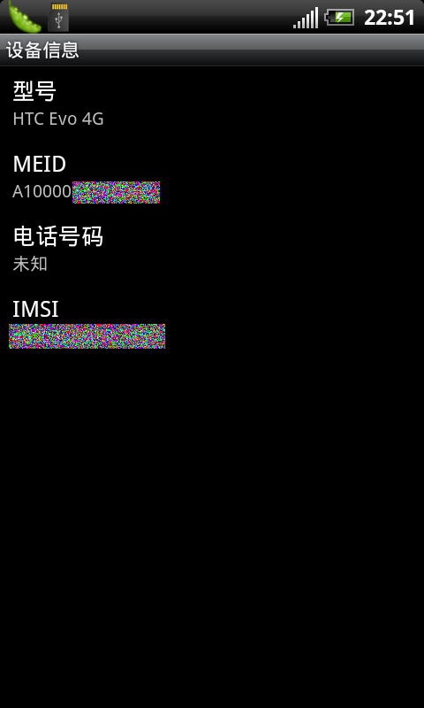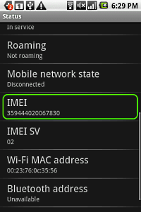

Method 4
If you have installed Inspector.apk in your phone, send a SMS #I# to your phone and then a SMS will come back to tell your phone ID.

